[Title]

**WILMER MATEO HERAS VERA**

**NF1013575**



Contents

Simulation Report: 2

Cooling Fan Replacement Policy Evaluation 2

1. Problem Description 2

2. Probability Distributions 2

2.1 Fan Lifetime Distribution 2

2.2 Technician Arrival Delay Distribution 3

3. Simulation Methodology - Python 3

3.1 Replacement Cost 4

3.2 Downtime Cost 5

3.3 Labor Cost 5

3.4 Total Cost per Failure 5

3.5 Time Advancement 5

4. Implementation Summary 5

5. Results and Visualization 6

6. Simulation Methodology - Excel 7

6. Conclusions and Recommendation 8

# Simulation Report: Cooling Fan Replacement Policy Evaluation

## Introduction

This report presents a Monte Carlo comparison of two fan replacement policies in a data center:

1. **Current Policy:** Replace only the failed fan on each failure event.
2. **Proposed Policy:** Replace all three fans whenever any one fails.

*We evaluate both:*

* Total cost over a fixed number of failures (45 failures).
* Cost per operational hour, tracking continuous fan aging and employing Common Random Numbers (CRN).

Statistical tests determine which policy is preferable under each metric.

***Fan Lifetime (hours)***

Top of Form

Bottom of Form

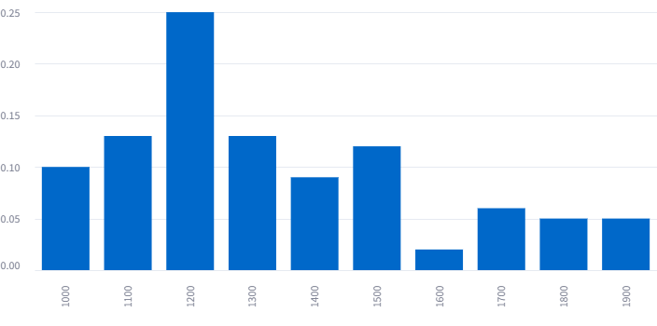

**Technician Arrival Delay (minutes)**

**Top of Form**

**Bottom of Form**

Top of Form

Bottom of Form

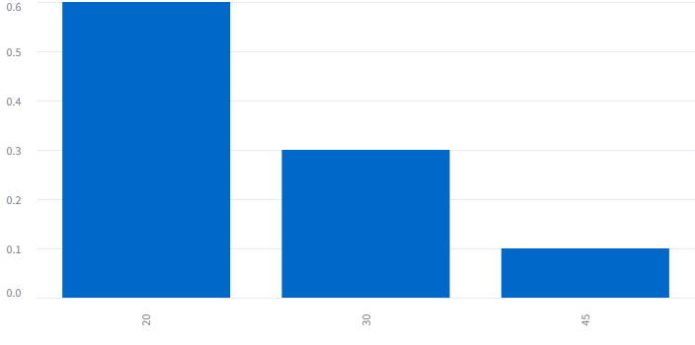

## Mathematical Formulation – Python Approach

## Downtime, Labor, and Fan Costs

Let

* $T_{\text{delay}}$ ​ = technician arrival delay (minutes)
* $T_{\text{replace}}$ ​ = replacement time (minutes)

$T_{\text{downtime}}=T_{\text{delay}}+T_{\text{replace}}​$

**Labor cost**

$$C_{\text{labor}}=\frac{T_{\text{downtime}}}{60}×R_{\text{labor}}​$$

**Fan cost**

$$C_{\text{fan}}=N_{\text{fans}}×C_{\text{fan}\text{_}\text{unit}}​$$

**Downtime cost**

$$C_{\text{downtime}}=T_{\text{downtime}}×R_{\text{downtime}}$$

**Total cost per failure**

$$C_{\text{failure}}=C_{\text{labor}}+C_{\text{fan}}+C_{\text{downtime}}​$$

## Aggregated Costs

For $n$ failures:

**Total cost over n failures**

$$C_{\text{total}}=\sum_{i=1}^{n}{C_{\text{failure}, i}}$$

**3. Cost Rate (Cost per Operational Hour)**

Tracking continuous aging of three fans:

* Let $t_{\text{fail}, i}=$ operating hours until the next failure event (minimum of three fan lifetimes).
* Total operational time $T_{oper}\sum_{i=1}^{n}{t_{fail,i}}$
* Total cost $C_{\text{total}}$ ​ as above.

**Cost per hour**

$$\text{CostRate}=\frac{C_{\text{total}}}{T_{\text{oper}}}​​$$

## Statistical Tests

**Two-sample Welch’s t-test (unequal variances)**

Comparing independent samples $X_{1},…,X_{n_{1}} and Y_{1},…,Y_{n_{2}}​​:$

$$t=\frac{\overline{X}-\overline{Y}}{\sqrt{\frac{s_{x}^{2}}{n_{1}^{}}+\frac{s_{y}^{2}}{n_{2}^{}}} }$$

**Paired t-test**

For paired observations $\left(X_{i},Y_{i}\right)$, differences $D_{i}=X_{i}-Y_{i}$ ​:

$$\overline{D}=\frac{1}{n}\sum_{i=1}^{n}{D_{i}}$$

$$s_{D}=\sqrt{\frac{1}{n-1}\sum_{i=1}^{n}{{\left(D_{i}-\overline{D}\right)}^{2}}}$$

$$t=\frac{\overline{D}}{s_{D}/\sqrt{n}}​$$

## Conclusions

* **Paired t-test (cost per hour)**:

$$t=101.154, \text{one-tailed }p=4.870×{10}^{-102}$$

*Proposed Policy has significantly lower cost per hour (α = 0.01).*

* **Two-sample t-test (total cost over 45 failures)**:

$$t=-159.738, p=1.095×{10}^{-205}$$

*Current Policy is significantly lower total cost (α = 0.05).*

## Recommendation

* If your objective is to **minimize cost per hour of server uptime**, adopt the **Proposed Policy** (replace all fans on any failure).
* If you must manage a **fixed budget over a set number of fan failures**, adopt the **Current Policy** (replace only the failed fan).

## 6. Simulation Methodology - Excel

Use the same sequence of random numbers to generate fan life and arrival time for both simulations for a more accurate comparison. It is to make sure that any difference in cost per operational time is due to the policy and not due to random chance in the sampling.

In “Replace one”, we are not treating each fan failure as independent, instead track the lifetime of 3 fans continuously, and replacing only the failed fan(s) while the others continue aging.

“Replace All” policy finishes simulation of 45 failures in more total operational time than for “Replace One” since each replacement cycle covers a longer period before needing repair.

**Column Descriptions and Calculations:**

|  |  |
| --- | --- |
| Column | Explanation |
| Failure Event | Repair event number (starts at 1, increments by 1) |
| Fan 1 Life (hours) | Lifetime (in hours) of Fan 1 before failure in the current cycle.  Sampled from fan life distribution (Table 1) |
| Fan 2 Life (hours) | Lifetime (in hours) of Fan 2. |
| Fan 3 Life (hours) | Lifetime (in hours) of Fan 3. |
| Time to Failure (hours) | The operating time before the first fan(s) fail among the 3. It's the minimum of the 3 lives. |
| Fans Replaced | Number of fans replaced during the event |
| Arrival Delay (minutes) | Time it takes for the technician to arrive after the failure is detected. Sampled from arrival time distribution (Table 2) |
| Replacement Time (minutes) | Time the technician spends replacing the fan(s) |
| Downtime (minutes) | Total time the system is down: Arrival Delay + Replacement Time. |
| Labor Time (minutes) | Time starts from dispatch until fan(s) replaced |
| Labor Cost ($) | Labor Time / 60 × $30 (technician is paid $30/hour) |
| Downtime Cost ($) | Downtime × $10 ($10 per minute of server outage) |
| Fan Cost ($) | Fans Replaced × $32 (each fan costs $32) |
| Total Cost ($) | Labor Cost + Downtime Cost + Fan Cost |
| Cost per hour ($/hour) | Normalized cost rate: Total Cost / Time to Failure, allowing fair comparison across policies. |

To test which policy performs better, we apply one tail t-test on **cost per hour**:

Since t-stat > CV at 1% alpha , we reject the null hypothesis, cost per hour is significantly lower under Proposed Policy: replace all whenever a fan fails compared to Current Policy: replace only the failed fan(s).

## 6. Conclusions and Recommendation

Empirical results show that while the Current Policy often incurs lower total cost, the Proposed Policy can yield shorter elapsed time to service the same number of failures, due to resetting all fan lifetimes.